MET CS 555 Assignment 4
Joseph Rissman
11/17/2024
- To get a sense of the data, generate a scatterplot to examine the association between prestige score and years of education. Briefly describe the form, direction, and strength of the association between the variables. Calculate the correlation coefficient.
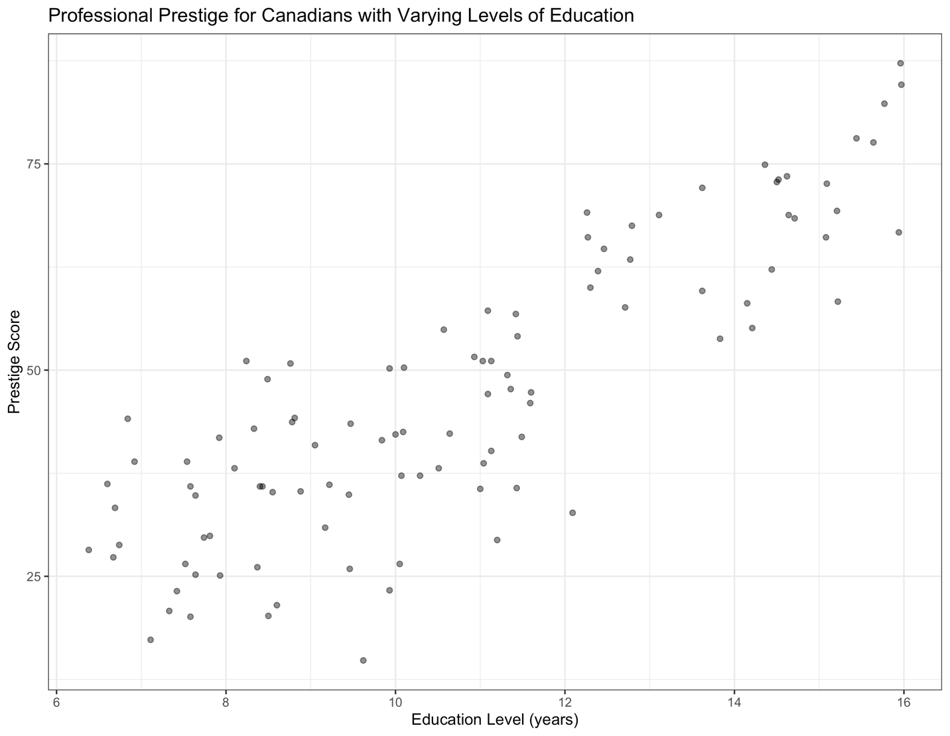
The variables are linearly correlated.
The variables are positively correlated.
The variables are strongly correlated.
The correlation coefficient is 0.8501769.

- Perform a simple linear regression with prestige score and years of education, and briefly summarize your conclusions (no need to do the 5-step procedure here). Generate a residual plot. Assess whether the model assumptions are met. Are there any outliers or influence points? If so, identify them by ID and comment on the effect of each on the regression.
The simple linear regression formula is:
$$\text{Prestige Score}=-10.731982+ 5.360878×\text{Years of Education}$$
The regression equation shows that for every additional year of education, the prestige score is expected to increase by 5.360878 points, on average. This suggests a positive relationship between years of education and prestige score. However, the intercept of -10.731982 indicates that someone with zero years of education would have a negative prestige score, which is not meaningful in this context. This demonstrates the limitations of extrapolating beyond the observed range of education levels.
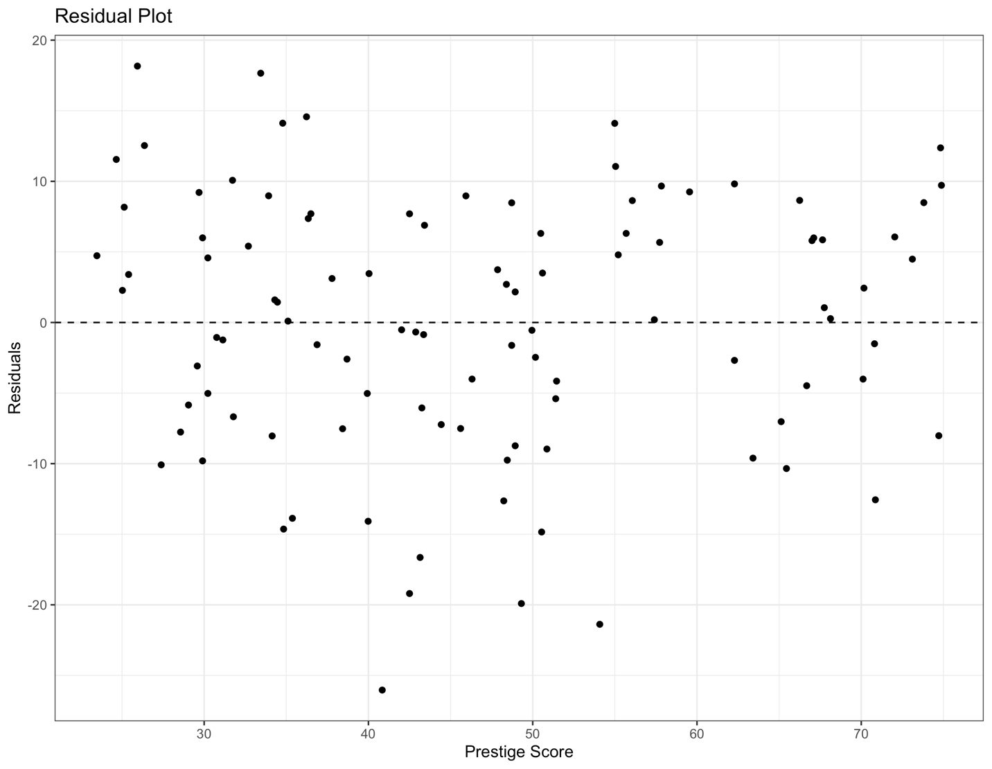
The linearity assumption is met because the points in the residual plot are randomly scattered around the horizontal line at zero. The homoscedasticity assumption is met because the spread of the points in the residual plot is consistent across the range of fitted values. The independence assumption is met because the prestige score of one profession does not influence the prestige score of other professions. The normality assumption is met because there are no significant deviations from a random scatter, like outliers or clusters.
There are no outliers of influence points based on an outlier score (see the 'check_outliers' function in the 'performance' R package; Lüdecke et al., 2021) determine by a Cook distance greater than 0.7.

- Calculate the least squares regression equation that predicts prestige score from education, income, and percentage of women. Formally test (using the 5-step procedure) whether the set of these predictors are associated with prestige score at the α = 0.05 level (Hint: You should be performing the global test).
The least squares regression equation is:
$$\text{Prestige Score}=-6.794334203+4.186637275×\text{Education Level (years)}×0.001313560×\text{Income (\$)}-0.008905157×\text{Percent of Workforce that are Wome}\text{n}$$
- Set up the hypotheses and select the alpha level.
$H_{0}⋮β_{education}=β_{income}=β_{women}=0$ (education level, income, and percent of workforce that are women are not significant predictors of prestige score)
$H_{a}⋮β_{education}≠0 \text{and/o}\text{r} β_{income}≠0 \text{and/o}\text{r} β_{women}≠0$ (at least one of the slope coefficients is different than 0; education level and/or income and/or percent of workforce that are women are significant predictors/is a significant predictor of prestige score)
$$α=0.05$$
- Select the appropriate test statistic.
$F=\frac{\text{MS Reg}}{\text{MS Res}}$ with $k=3$ and $n-k-1=98$ degrees of freedom.
- State the decision rule.
F-distribution with 3, 98 degrees of freedom and associated with $α=0.05$
$$F_{3,98,0.05}=2.697423$$
Decision Rule: Reject $H_{0}$ if $F≥2.697423$
Otherwise, do not reject $H_{0}$
- Compute the test statistic.
$$\text{Reg MS}=\frac{\text{Reg SS}}{\text{Reg }\text{df}}=\frac{23861.86}{3}=7953.952$$
$$\text{Res MS}=\frac{\text{Res SS}}{\text{Res }\text{df}}=\frac{6033.57}{98}=61.56704$$
$$F=\frac{\text{MS Reg}}{\text{MS Res}}=\frac{7953.952}{61.56704}=129.1917$$
- State the conclusion.
Reject $H_{0}$ since $F≥2.697423$. We have significant evidence at the $α=0.05$ level that $β_{education}≠0 \text{and/o}\text{r} β_{income}≠0 \text{and/o}\text{r} β_{women}≠0$. There is evidence of a linear association between prestige score and education level and/or income and/or percentage of workforce that are women. (here, p-value < 2.2e-16 as calculated using R)

- If the overall model was significant, summarize the information about the contribution of each variable separately at the same significance level as used for the overall model (no need to do a formal 5-step procedure for each one, just comment on the results of the tests). Provide interpretations for any estimates (of the slopes) that are significant. Calculate 95% confidence intervals for any estimates that are significant.
 | Estimate | Std. Error | t value | Pr(>|t|)
Education Level (years) | 4.1866373 | 0.3887013 | 10.771 | < 2e-16
Income ($) | 0.0013136 | 0.0002778 | 4.729 | 7.58e-06
Percent of Workforce that are Women | -0.0089052 | 0.0304071 | -0.293 | 0.7702
The critical t-value is $t_{98,0.025}=1.984467$.
There is evidence at the $α=0.05$ level that there is a linear association between prestige score and education level. The estimate of the slope shows that for every additional year of education, the prestige score is expected to increase by 4.1866373 points, on average, after controlling for the other variables.
$${\hat{β}}_{education} ±t_{98,0.025}×SE_{{\hat{β}}_{education}}=4.1866373±1.984467×0.3887013=4.1866373±0.7713649$$
The 95% confidence interval for the estimate of the slope of prestige score w.r.t. education level is (3.415272, 4.958002).
There is evidence at the $α=0.05$ level that there is a linear association between prestige score and income. The estimate of the slope shows that for every additional dollar of income, the prestige score is expected to increase by 0.0013136 points, on average, after controlling for the other variables.
$${\hat{β}}_{income} ±t_{98,0.025}×SE_{{\hat{β}}_{income}}=0.0013136±1.984467×0.0002778=0.0013136±0.0005512849$$
The 95% confidence interval for the estimate of the slope of prestige score w.r.t. income is (0.000762, 0.001865).

- Generate a residual plot showing the fitted values from the regression against the residuals. Is the fit of the model reasonable? Are there any outliers or influence points?
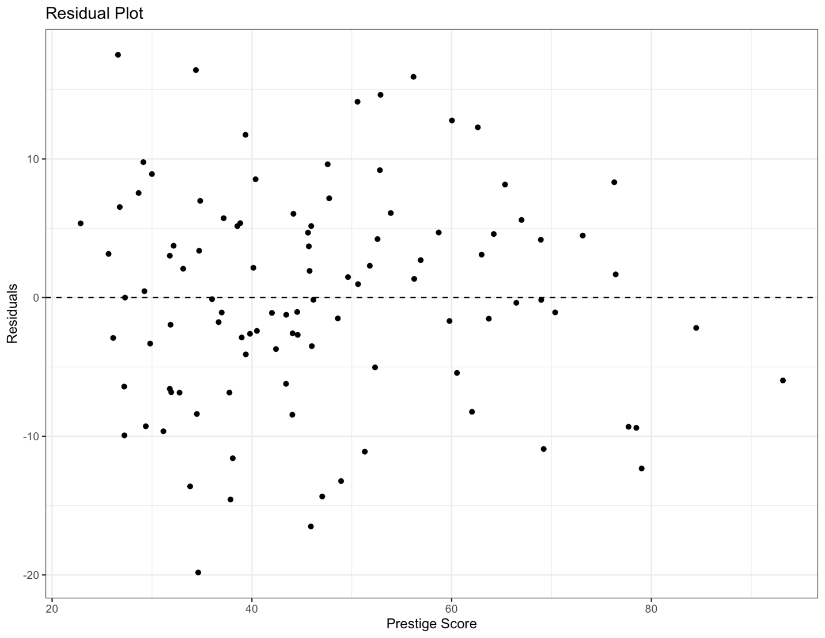
The fit of the model appears to be reasonable based on the residual plot. There appears to be a slight cone shape such that the standard errors decrease with higher prestige score. This suggests there might be some heteroscedasticity present in the model.
There are no outliers of influence points based on an outlier score (see the 'check_outliers' function in the 'performance' R package; Lüdecke et al., 2021) determine by a Cook distance greater than 0.845.

R code for Assignment 4
# CS555 Homework Assignment 4
# Load necessary libraries ------------------------------------------------

library(readxl)
library(dplyr)
library(tidyr)
library(ggplot2)
library(easystats)

# Import and clean data ---------------------------------------------------

data <- read_excel("Homework 4/Homework 4 Data.xlsx", col_names = TRUE)

# Problem 1 ---------------------------------------------------------------

# Generate a scatter plot
gg <- ggplot(data, aes(x = `Education Level (years)`, y = `Prestige Score`)) +
geom_point(alpha = 0.5) +
labs(
title = "Professional Prestige for Canadians with Varying Levels of Education"
) +
theme_bw()
plot(gg)
ggsave("Homework 4/scatter.png")

# Calculate the correlation coefficient.
cor(data$`Education Level (years)`,data$`Prestige Score`)

# Problem 2 ---------------------------------------------------------------

# Perform a simple linear regression.
model <- lm(`Prestige Score` ~ `Education Level (years)`, data)
coef(model)

# Generate a residual plot.
residuals <- model$residuals
fitted_values <- model$fitted.values
residual_data <- data.frame(fitted_values, residuals)
gg <- ggplot(residual_data, aes(x = fitted_values, y = residuals)) +
geom_point() +
geom_hline(
yintercept = 0,
linetype = "dashed",
color = "black"
) +
labs(
x = "Prestige Score",
y = "Residuals",
title = "Residual Plot"
) +
theme_bw()
plot(gg)
ggsave("Homework 4/residual_slr.png")

# Identify outliers and influence points.
outliers_list <- check_outliers(model)
outliers_list
plot(outliers_list)

# Problem 3 ---------------------------------------------------------------

# Calculate the least squares regression equation.
model <- lm(`Prestige Score` ~ `Education Level (years)` + `Income ($)` + `Percent of Workforce that are Women`, data)
summary(model)

# Calculate the critical F-score.
qf(0.95,3,98)

# Calculate F-score of model.
totalss <- sum((data$`Prestige Score` - mean(data$`Prestige Score`))^2)
regss <- sum((fitted(model) - mean(data$`Prestige Score`))^2)
resiss <- sum((data$`Prestige Score` - fitted(model))^2)
fstatistic <- (regss/3)/(resiss/98)

# Problem 4 ---------------------------------------------------------------

# Summarize the information about the contribution of each variable.
summary(model)

# Calculate the critical t-value.
qt(0.975,98)

# Calculate the 95% confidence intervals.
confint(model, level = 0.95)

# Problem 5 ---------------------------------------------------------------

# Generate a residual plot.
residuals <- model$residuals
fitted_values <- model$fitted.values
residual_data <- data.frame(fitted_values, residuals)
gg <- ggplot(residual_data, aes(x = fitted_values, y = residuals)) +
geom_point() +
geom_hline(
yintercept = 0,
linetype = "dashed",
color = "black"
) +
labs(
x = "Prestige Score",
y = "Residuals",
title = "Residual Plot"
) +
theme_bw()
plot(gg)
ggsave("Homework 4/residual_mlr.png")

# Identify outliers and influence points.
outliers_list <- check_outliers(model)
outliers_list
plot(outliers_list)

